# **Z Capstone Project: Applied Statistics**

**-Bathula Niharika**

**1.What is a vector in mathematics**

A vector in mathematics is a quantity that has both a magnitude and a direction. Magnitude refers to the size of the vector, and direction refers to the way it is pointing. Vectors are often represented by arrows, with the length of the arrow representing the magnitude of the vector and the direction of the arrow representing the direction of the vector.

Vectors are used in many different areas of mathematics, including physics, engineering, and computer science. Some examples of vectors include:

* Force
* Velocity
* Acceleration

Vectors can be added and subtracted using the head-to-tail method.Vectors can also be multiplied by scalars. A scalar is a quantity that has only a magnitude. When a vector is multiplied by a scalar, the magnitude of the vector is multiplied by the scalar. The direction of the vector remains the same.

Here is an example of a vector in mathematics:

Suppose you are standing at a point on the ground and you throw a ball up into the air. The ball's velocity is a vector. The magnitude of the velocity vector is the speed of the ball, and the direction of the velocity vector is the direction in which the ball is moving.

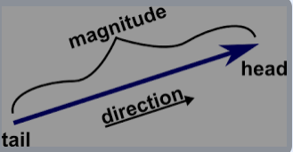

**2.How is a vector different from a scalar?**

A scalar quantity is different from a vector quantity in terms of direction. Scalars don’t have direction, whereas a vector has. Due to this feature, the scalar quantity can be said to be represented in one dimension, whereas a vector quantity can be multi-dimensional. From the table given below, let us learn more differences between scalars and vectors.

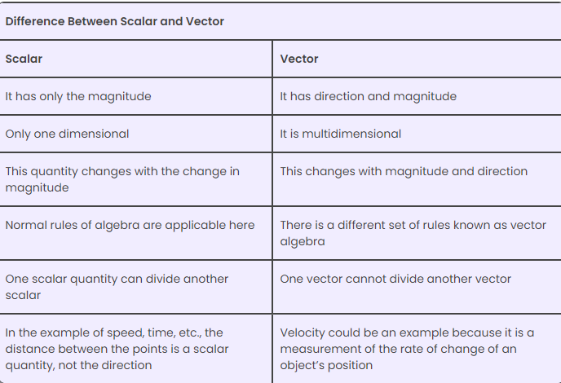

**3.How can vectors be multiplied by a scalar?**

To multiply a vector by a scalar, multiply each component of the vector by the scalar.

Vectors can be multiplied by a scalar (a real number) through a process called scalar multiplication. Scalar multiplication involves multiplying each component of the vector by the scalar value. This operation scales the magnitude of the vector while keeping its direction (if the scalar is positive) or reversing its direction (if the scalar is negative). The resulting vector is parallel to the original vector and has a magnitude equal to the product of the scalar and the original vector's magnitude.

Here's the general formula for scalar multiplication of a vector v by a scalar "a":

Scalar multiplication: a v = (a * v₁, a * v₂, a * v₃, ..., a * vᵣ)

Where:

* "a" is the scalar (a real number).
* v is the vector with components (v₁, v₂, v₃, ..., vᵣ).
* The result is a new vector, and each component of the new vector is obtained by multiplying the corresponding component of the original vector by the scalar "a."

If "a" is positive, the resulting vector will have the same direction as the original vector but with a magnitude scaled by the value of "a." If "a" is negative, the resulting vector will have the same direction as the original vector but with its magnitude scaled and reversed in direction.

Here are a few examples of scalar multiplication:

* Scalar multiplication by a positive scalar:
  + v = (2, 3)
  + 2 v = (2 * 2, 2 * 3) = (4, 6)
* In this case, the vector v is scaled up by a factor of 2, resulting in a new vector that is twice as long as the original vector in the same direction.
* Scalar multiplication by a negative scalar:
  + v = (-1, 4)
  + (-2) v = (-2 * -1, -2 * 4) = (2, -8)
* Here, the vector v is scaled by a factor of -2, resulting in a vector with the same direction but reversed in direction and doubled in magnitude.
* Scalar multiplication is a fundamental operation in vector algebra and is used in many different areas.

**4.How can the direction of a vector be determined?**

The direction of a vector is the angle it makes with the positive x-axis. The angle is measured in a counterclockwise direction, starting at 0 degrees on the positive x-axis. A vector can point in any direction in the plane, from 0 to 360 degrees.

To find the direction of a vector, you can:

* Start at the positive x-axis (0 degrees).
* Move counterclockwise until you get to the vector.
* The angle between the positive x-axis and the vector is the direction of the vector.

The direction of a vector is defined with respect to a given frame of reference. For example, the acceleration due to gravity is downwards because the top line of the fraction is a vector in the downward direction.

You can use the following formulas to find the direction of a vector:

* Sin cos formula
* Cos Inverse Formula
* Sin Theta formula
* Tan2x formula
* Tan Theta Formula

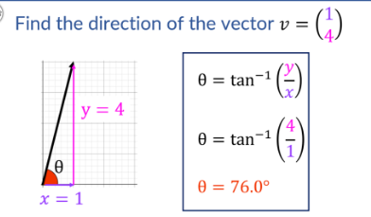

**5. What is a linear transformation in linear algebra?**

In linear algebra, a linear transformation is a function that maps one vector space to another. It preserves the operations of vector addition and scalar multiplication.

A linear transformation is also known as:

* A linear operator
* A linear map
* A vector space homomorphism
* A linear function

A linear transformation satisfies the following properties:

* T(x + y) = T(x) + T(y)
* T(ax) = aT(x)

Examples of linear transformations include: Dilations, Shears, Rotations, Reflections, Projections. If a translation is not linear, something is being lost or gained when the vectors are added together and then transformed, or when they are transformed then added together.

**6.What is an eigenvector in linear algebra?**

In linear algebra, an eigenvector is a nonzero vector that changes at most by a constant factor when a linear transformation is applied to it. Eigenvectors are also known as: Characteristic vectors, Proper vectors, Latent vectors.

Eigenvectors are associated with a linear system of equations.

When a transformation matrix is applied to an eigenvector, the vector is only stretched, with no rotation or shear. The corresponding eigenvalue is the multiplying factor. If the eigenvalue is negative, the direction is reversed.

A vector v is an eigenvector of a square matrix A if and only if:

* Av = λv, for some scalar λ

You can find the eigenvalues λ of a matrix A by solving the equation:

* det(λI−A)=0

For each λ, you can find the basic eigenvectors X≠0 by finding the basic solutions to:

* (λI−A)X=0

**7. What is the gradient in machine learning?**

In machine learning, a gradient is the slope or rate of change of a function with respect to its parameters. It's a vector that contains the partial derivatives of a function.

A gradient measures the change in all weights with regard to the change in error. The higher the gradient, the steeper the slope and the faster a model can learn. If the slope is zero, the model stops learning.

A gradient is used in gradient descent. In gradient descent, you try to minimize a loss function of many variables by following the negative of the gradient of the function. The size of the step is controlled by the learning rate, which determines how quickly the algorithm moves towards the minimum.

A gradient tells us the direction of the steepest ascent. By moving in the opposite direction, we can find the direction of the steepest descent.

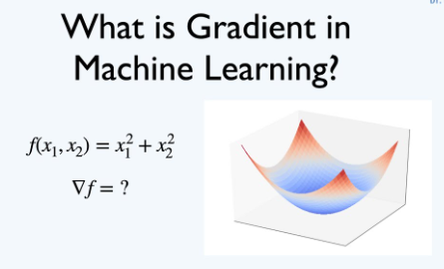

**8. What is backpropagation in machine learning?**

Backpropagation is an algorithm that tests for errors by working back from output nodes to input nodes. It's a standard method of training artificial neural networks.

Backpropagation is used to:

* Improve the accuracy of predictions in data mining and machine learning
* Fine-tune the weights of a neural net based on the error rate from the previous epoch
* Adjust the model's parameters based on weights and biases
* Find the derivatives for the loss or error with respect to every single weight in the network
* Update these weights in the direction opposite to their respected derivatives

Backpropagation is a very powerful algorithm, but it can be difficult to train neural networks using backpropagation. This is because neural networks can have many parameters (weights), and it can be difficult to find the right combination of parameters to minimize the error. However, there are a number of techniques that can be used to improve the performance of backpropagation, such as regularization and momentum.

**9.What is the concept of a derivative in calculus?**

In calculus, a derivative is the rate of change of a quantity y with respect to another quantity x. It can also be thought of as the slope of a line that is tangent to a specific function's curve.

Derivatives are essential in mathematics because we always observe changes in systems.

The process of finding the derivative of a function is called differentiation.

Derivatives can be defined in multiple ways, including:

The rate of change of a quantity y with respect to another quantity x

The slope of a line that is tangent to a specific function's curve

The limit of the difference quotient's expression as the input approaches zero

The instantaneous rate of change of a function with respect to one of its variables

The limit of the instantaneous rate of change of the function as the time between measurements decreases to zero.

In summary, the derivative is a central concept in calculus, allowing us to understand how functions change and providing a tool for various mathematical and scientific applications. It is a key component of both differential calculus (concerned with derivatives) and integral calculus (concerned with integrals).

**10.What is probability theory?**

Probability theory is a branch of mathematics that analyzes the likelihood of random events. It uses a set of axioms to express probability in a rigorous mathematical manner.

In probability theory, the probability of an event is a number between 0 and 1. 0 indicates impossibility and 1 indicates certainty.

Probability theory is used to analyze random events such as:

Rolling a die

Dealing a bridge hand from a shuffled deck of cards

The life of an electric bulb

The minimum and maximum temperatures in a city on a certain day

Probability theory is essential to many human activities that involve quantitative analysis of data. It is the mathematical foundation for statistics.

Probability theory can be used to calculate the probability of any event, no matter how complex. For example, we can use probability theory to calculate the probability of getting at least one head when flipping two coins, or the probability of rolling two dice and getting a sum of 7.

Probability theory is a powerful tool for understanding and analyzing the world around us. It is used in many different fields to make predictions, to make decisions about risk, and to design algorithms.

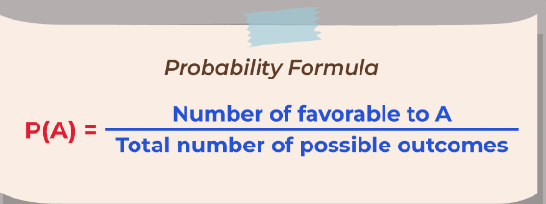

**11. What is conditional probability, and how is it calculated?**

Conditional probability is the likelihood of an event occurring, based on the occurrence of a previous event. It is calculated by multiplying the probability of the preceding event by the updated probability of the succeeding, or conditional, event.

The formula for conditional probability is:

* P(A | B) = P(A ∩ B) / P(B):

Here are some examples of conditional probability:

* The conditional probability that someone who is sick is coughing might be 75%. In this case, P(Cough) = 5% and P(Cough|Sick) = 75%.
* The probability of the second card being red is dependent on the first card being red.
* When A and B are independent, the formula is P(A and B) = P(A) * P(B). When A and B are dependent, the formula is P(A and B)

**12.What is Bayes theorem, and how is it used?**

Bayes' theorem is a mathematical model that calculates the probability of an event based on its relationship with another event. It's also known as Bayes' rule, Bayes' law, or Bayesian reasoning.

Bayes' theorem is used to:

* Calculate the probability of one scenario based on its relationship with another scenario
* Determine how the probability of an event occurring may be affected by hypothetical new information
* Find the probability of an event with uncertain knowledge
* Relate the conditional probability and marginal probabilities of two random events

Bayes' theorem is named after Reverend Thomas Bayes.

Here's an example of how Bayes' theorem can be used:

* A patient goes to see a doctor.
* The doctor performs a test with 99 percent reliability.
* The probability of a patient having cancer given a positive test result can be calculated using Bayes' theorem.The equation for this scenario is:P(Cancer=True | Test=Positive) = P(Test=Positive|Cancer=True) *P(Cancer=True) / P(Test=Positive)
* 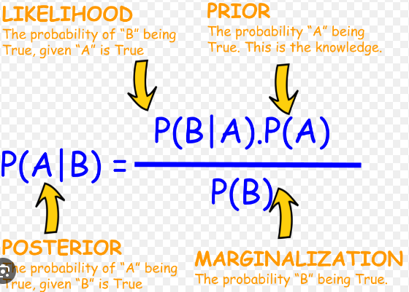

**13.What is a random variable, and how is it different from a regular variable?**

A random variable is a variable whose value is determined by chance. It is a function that maps the outcomes of a random experiment to a set of numerical values. Regular variables, on the other hand, are variables whose values are known or can be determined.

Here is an example:

* Regular variable: The number of students in a classroom. This variable can be determined by counting the students in the classroom.
* Random variable: The outcome of a coin toss. This variable is random because we cannot predict with certainty whether the coin will land on heads or tails.

Random variables are often used in statistics and probability to model and analyze random phenomena.Random variables are different from regular variables in a few important ways:

* Random variables can take on multiple values, while regular variables can only take on one value at a time.
* Random variables are associated with a probability distribution, which describes the likelihood of each possible value of the variable. Regular variables do not have a probability distribution.
* Algebraic operations performed on random variables may not be valid for regular variables. For example, the sum of two random variables may not be equal to the sum of the two variables themselves.

**14.What is the central limit theorem, and how is it used?**

The Central Limit Theorem (CLT) is a fundamental concept in statistics that describes the behavior of the sampling distribution of the sample mean (or other sample statistics) as the sample size increases. In essence, it states that if you take repeated random samples of a population, calculate the means of these samples, and plot the distribution of those means, that distribution will become approximately normal (i.e., it will have a bell-shaped curve) regardless of the shape of the original population distribution.

The CLT has several applications. Look at the places where you can use it.

* Political/election polling is a great example of how you can use CLT. These polls are used to estimate the number of people who support a specific candidate. You may have seen these results with confidence intervals on news channels. The CLT aids in this calculation.
* You use the CLT in various census fields to calculate various population details, such as family income, electricity consumption, individual salaries, and so on.

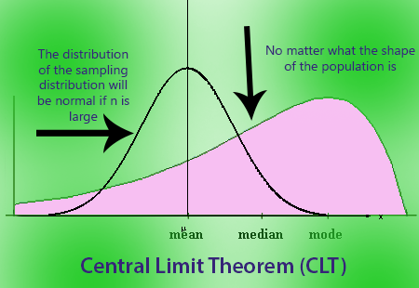

**15.What is the difference between discrete and continuous probability distributions?**

In probability theory, discrete and continuous distributions are two fundamental concepts. Discrete distributions are when a random variable can only take on a finite or countable number of values. Continuous distributions are when a random variable can take on any value within a certain range or interval.Discrete probability distributions:

* + Binomial distribution: The probability of getting a certain number of successes in a sequence of independent trials.
  + Poisson distribution: The probability of getting a certain number of events in a fixed interval of time or space.
  + Hypergeometric distribution: The probability of selecting a certain number of successes from a population without replacement.
* Continuous probability distributions:
  + Normal distribution: The probability of getting a certain value for a variable that follows a normal distribution.
  + Exponential distribution: The probability of getting a certain amount of time until an event occurs.
  + Uniform distribution: The probability of getting a certain value for a variable that is uniformly distributed within a certain range.

Discrete and continuous probability distributions are both important tools for modeling and analyzing random phenomena. They are used in a wide variety of fields, including statistics, probability, machine learning, and artificial intelligence.

**16.What are some common measures of central tendency, and how are they calculated?**

The three most common measures of central tendency are the mean, median, and mode.

Mean: The mean, also known as the average, is calculated by adding up the values of all the data points and dividing by the number of data points.

Median: The median is the middle value of a set of data points when the data points are arranged in order from least to greatest. If there are two middle values, the median is the average of those two values.

Mode: The mode is the most frequently occurring value in a set of data points.

The mean, median, and mode can all be useful for describing the central tendency of a set of data. However, they have different strengths and weaknesses.

The mean is the most commonly used measure of central tendency because it is easy to calculate and interpret. However, the mean can be skewed by outliers, which are data points that are much higher or lower than the rest of the data.

The median is not affected by outliers, so it is a good measure of central tendency for data sets that contain outliers. However, the median can be difficult to calculate for large data sets.

The mode is the simplest measure of central tendency to calculate, but it is not as informative as the mean or median. This is because the mode only tells us the most frequently occurring value in the data set. It does not tell us anything about the other values in the data set.

Which measure of central tendency is most appropriate to use depends on the specific data set and the question being asked.

Here are some additional things to keep in mind when choosing a measure of central tendency:

* The mean is the most appropriate measure of central tendency for data sets that are normally distributed.
* The median is the most appropriate measure of central tendency for data sets that are not normally distributed or that contain outliers.
* The mode is the most appropriate measure of central tendency for data sets that are categorical or that contain a large number of outliers.

**17.How do you use the central limit theorem to approximate a discrete probability distribution?**

The central limit theorem (CLT) states that the distribution of the sample mean of a sufficiently large random sample from a population will be approximately normally distributed, regardless of the distribution of the population.

This means that we can use the CLT to approximate the probability distribution of a discrete random variable by taking a sufficiently large sample of values from the random variable and then calculating the distribution of the sample mean.

To approximate a discrete probability distribution using the CLT, we can follow these steps:

1. Take a sufficiently large random sample of values from the discrete random variable.
2. Calculate the mean and standard deviation of the sample.
3. Use the standard normal table to approximate the probability of the sample mean being less than or equal to a certain value.

For example, suppose we want to approximate the probability of getting 4 heads in a sequence of 10 coin flips. The discrete random variable in this case is the number of heads in a sequence of 10 coin flips.

We can take a random sample of 10 coin flips and calculate the number of heads in the sample. We can then repeat this process many times to get a distribution of sample means.

The CLT tells us that the distribution of sample means will be approximately normally distributed, with a mean of 5 and a standard deviation of 1.58.

We can then use the standard normal table to approximate the probability of the sample mean being less than or equal to 4. This probability is approximately 0.3821.

Therefore, the probability of getting 4 heads in a sequence of 10 coin flips is approximately 0.3821.

The CLT is a powerful tool for approximating discrete probability distributions. It is used in a wide variety of fields, including statistics, probability, machine learning, and artificial intelligence.

Here are some additional things to keep in mind when using the CLT to approximate a discrete probability distribution:

* The CLT is more accurate for larger sample sizes.
* The CLT is less accurate for discrete random variables with a small number of possible values.
* The CLT is less accurate for discrete random variables with a skewed distribution.

Despite these limitations, the CLT is a valuable tool for approximating discrete probability distributions.

**18**.**What is a joint probability distribution?**

A joint probability distribution is a probability distribution for two or more random variables. It's based on joint probability, which is the probability of two events happening together. The main purpose of a joint probability distribution is to look for a relationship between two variables.

**The formula for a joint probability distribution is:**

* f(x,y) = P(X = x, Y = y):

**A joint probability distribution encodes:**

* The marginal distributions, which are the distributions of each of the individual random variables
* The conditional probability distributions, which deal with how the outputs of one random variable are distributed when given information on the outputs of the other random variable

**Here are some examples of joint probability distributions:**

* The joint probability of picking a card that is both red and 6 from a deck is P(6 ∩ red) = 2/52 = 1/26.
* The number of people in a family, the household income, and the ages of the family members.
* The probability of it being windy and not raining is 0.16 (or 16%).

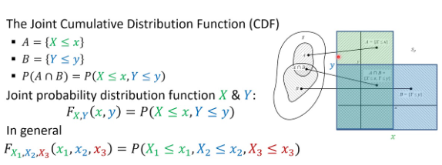

**19.What is the difference between a joint probability distribution and a marginal probability distribution?**

Joint probability distribution and marginal probability distribution are concepts in probability theory, often used in the context of multiple random variables. Here's the key difference between the two:

* Joint Probability Distribution:
  + A joint probability distribution represents the probabilities associated with the outcomes of multiple random variables considered together. It provides a complete description of the probability of all possible combinations of values for those variables.
  + When you have two or more random variables, a joint probability distribution describes how the variables co-occur or interact.
  + In the case of two random variables X and Y, the joint probability distribution is often denoted as P(X, Y) or P(X and Y).
  + It gives you information about the probability of observing specific pairs or combinations of values for the random variables. For example, P(X = x, Y = y) represents the probability that X takes on the value x and Y takes on the value y simultaneously.
  + Joint probability distributions are used in problems involving multiple variables and conditional probability calculations.
* Marginal Probability Distribution:
  + A marginal probability distribution, on the other hand, provides the probabilities associated with individual random variables in isolation, ignoring the other variables. It's derived from the joint probability distribution.
  + Marginal probabilities describe the probability distribution of each variable independently of the others.
  + If you have a joint probability distribution P(X, Y) for two variables X and Y, the marginal probability distribution for X is denoted as P(X) and represents the probabilities of different values of X without considering the values of Y. Similarly, the marginal probability distribution for Y is denoted as P(Y) and describes the probabilities of different values of Y without considering X.
  + Marginal probability distributions are often used to answer questions like, "What is the probability distribution of variable X, regardless of what happens with Y?"

In summary, the key distinction is that a joint probability distribution involves multiple random variables and considers their interactions, while a marginal probability distribution focuses on a single random variable and represents its probabilities in isolation from the others. Marginal probabilities are obtained by summing or integrating the joint probabilities over the other variables.

**20.What is the covariance of a joint probability distribution?**

The covariance of a joint probability distribution is a measure of the linear relationship between two random variables. It is calculated by taking the expected value of the product of the deviations of the two random variables from their means.

The formula for covariance is:

Cov(X, Y) = E[(X - E[X]) (Y - E[Y])]

where:

* X and Y are two random variables.
* E[X] and E[Y] are the expected values of X and Y, respectively.

The covariance can be positive, negative, or zero. A positive covariance indicates that the two random variables tend to move in the same direction, meaning that when one random variable increases, the other random variable also tends to increase. A negative covariance indicates that the two random variables tend to move in opposite directions, meaning that when one random variable increases, the other random variable tends to decrease. A covariance of zero indicates that the two random variables are not linearly related.

The covariance is a useful measure for understanding the relationship between two random variables. It is used in a wide variety of fields, including statistics, probability, machine learning, and artificial intelligence.

The covariance is a powerful tool for understanding and modeling the relationships between random variables.

**21**.**What is the relationship between the correlation coefficient and the covariance of a joint probability distribution?**

The correlation coefficient is a normalized version of the covariance. It is calculated by dividing the covariance by the product of the standard deviations of the two random variables.

The formula for the correlation coefficient is:

ρ(X, Y) = Cov(X, Y) / (σ_X σ_Y)

where:

* ρ(X, Y) is the correlation coefficient between X and Y.
* Cov(X, Y) is the covariance between X and Y.
* σ_X and σ_Y are the standard deviations of X and Y, respectively.

The correlation coefficient is a measure of the strength and direction of the linear relationship between two random variables. It can range in value from -1 to 1, with a value of -1 indicating a perfect negative correlation, a value of 0 indicating no correlation, and a value of 1 indicating a perfect positive correlation.

The correlation coefficient is a more useful measure of the relationship between two random variables than the covariance because it is standardized. This means that the correlation coefficient is not affected by the scale of the two random variables.

The correlation coefficient is a more useful measure of the relationship between two random variables than the covariance because it is standardized. It is used in a wide variety of fields to understand and model the relationships between random variables.

**22.What is sampling in statistics, and why is it important?**

In statistics, sampling is the process of selecting a part of a population to obtain data for analysis. Sampling is important because it makes data collection easier, faster, and cheaper. It also allows researchers to draw conclusions about complex situations.

**Sampling is important because it allows researchers to:**

* Collect and analyze data for a smaller portion of the population
* Apply the results to the whole population
* Draw conclusions about complex situations
* Determine a population's characteristics by directly observing only a portion of the population

In summary, sampling is a fundamental concept in statistics that plays a crucial role in data collection, analysis, and decision-making. It allows researchers and analysts to make inferences about a population, control costs, reduce bias, and make data-driven decisions with confidence. Properly designed and executed sampling methods are essential for obtaining reliable and accurate information from a subset of a larger group.

**23.What are the different sampling methods commonly used in statistical inference?**

There are two main types of sampling methods commonly used in statistical inference: probability sampling and non-probability sampling.

Probability sampling is a type of sampling where every member of the population has a known and equal chance of being selected. This type of sampling is the most accurate, but it can also be the most difficult and expensive to implement.

Some common probability sampling methods include:

* Simple random sampling: Every member of the population is assigned a unique number, and then a random sample is selected by drawing numbers from a hat or using a random number generator.
* Stratified sampling: The population is divided into strata (subgroups), and then a random sample is selected from each stratum. This method is used to ensure that all subgroups of the population are represented in the sample.
* Cluster sampling: The population is divided into clusters (groups), and then a random sample of clusters is selected. All members of the selected clusters are then included in the sample. This method is often used when it is difficult or expensive to identify individual members of the population.

Non-probability sampling is a type of sampling where not every member of the population has an equal chance of being selected. This type of sampling is less accurate than probability sampling, but it is also easier and less expensive to implement.

Some common non-probability sampling methods include:

* Convenience sampling: The researcher selects the sample based on convenience, such as by selecting people who are easy to access.
* Voluntary response sampling: The researcher selects the sample from people who volunteer to participate.
* Purposive sampling: The researcher selects the sample based on a specific purpose, such as selecting people who have a particular characteristic or who are experts in a particular field.

Sampling is an important part of statistical inference. By choosing the right sampling method, you can collect data that will allow you to make accurate and reliable inferences about your population of interest.

**24. What is the difference between parameter estimation and hypothesis testing?**

Parameter estimation and hypothesis testing are two fundamental aspects of statistical inference, but they serve different purposes and involve distinct concepts. Here's an overview of the key differences between them:

**Parameter Estimation**:

* **Purpose**: Parameter estimation is primarily used to determine or estimate specific characteristics or parameters of a population. These parameters might include the population mean, population proportion, population variance, or other descriptive statistics.
* **Process**: To estimate a parameter, you collect a sample from the population and calculate a point estimate (e.g., sample mean, sample proportion) that provides an estimate of the corresponding population parameter.
* **Uncertainty**: In parameter estimation, you often want to quantify the uncertainty associated with your point estimate. This leads to the concept of confidence intervals, which provide a range of values within which you believe the true population parameter lies with a certain level of confidence.
* **Examples**: Estimating the average height of all adults in a country, estimating the proportion of customers satisfied with a product, or estimating the standard deviation of test scores in a school.

**Hypothesis Testing:**

* **Purpose**: Hypothesis testing is used to make decisions about population parameters based on sample data. It's a way to assess whether a specific claim or hypothesis about a population parameter is supported by the evidence.
* **Process**: In hypothesis testing, you start with a null hypothesis (H0), which represents the status quo or a specific claim, and an alternative hypothesis (Ha), which represents what you want to test. You collect sample data and use statistical tests to determine whether there is enough evidence to reject the null hypothesis in favor of the alternative hypothesis.
* **Outcome:** The result of a hypothesis test is typically a p-value, which measures the strength of the evidence against the null hypothesis. If the p-value is sufficiently small (below a chosen significance level), you reject the null hypothesis. If the p-value is not small, you fail to reject the null hypothesis.
* **Examples:** Testing whether a new drug is effective (null hypothesis: it is not effective), determining if a new advertising campaign increases sales (null hypothesis: it has no effect), or assessing whether a new teaching method improves student performance (null hypothesis: it has no effect).

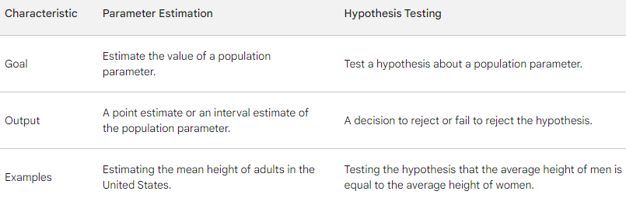

**25.What is the p-value in hypothesis testing?**

In hypothesis testing, the p-value (short for "probability value") is a statistical measure that quantifies the strength of the evidence against a null hypothesis. The p-value helps you make a decision about whether to reject the null hypothesis in favor of an alternative hypothesis.

Here's how the p-value works in hypothesis testing:

* Null Hypothesis (H0): The null hypothesis is a statement or assumption about a population parameter, often representing the status quo or a specific claim. It is typically denoted as H0.
* Alternative Hypothesis (Ha): The alternative hypothesis is the statement you want to test or the claim you hope to support. It represents a departure from the null hypothesis and is often denoted as Ha.
* Collect Data: You collect a sample from the population and calculate a test statistic, which is a numerical value based on the sample data. The choice of the test statistic depends on the specific hypothesis test being conducted.
* Calculate the p-value: The p-value is calculated using the test statistic and reflects the probability of obtaining a test statistic as extreme as, or more extreme than, the one observed in the sample if the null hypothesis were true.
* Make a Decision: The p-value is compared to a predetermined significance level (α), typically set at a small value like 0.05. The significance level represents the threshold for statistical significance. There are three possible outcomes:
  + If the p-value is less than or equal to α, you reject the null hypothesis in favor of the alternative hypothesis. This suggests that there is strong evidence against the null hypothesis.
  + If the p-value is greater than α, you fail to reject the null hypothesis. This means that the data do not provide sufficient evidence to support the alternative hypothesis.
  + The p-value should not be interpreted as proving the null hypothesis. Instead, it provides a measure of the strength of the evidence against it.

In essence, a smaller p-value indicates stronger evidence against the null hypothesis, while a larger p-value suggests weaker evidence against the null hypothesis. The specific interpretation of the p-value depends on the chosen significance level (α) and the context of the hypothesis test.

It's important to note that the p-value is a probability measure and does not provide information about the magnitude or practical significance of an effect. It only helps you assess the statistical significance of the observed results in relation to the null hypothesis.

**26.What are Type I and Type II errors in hypothesis testing?**

In hypothesis testing, Type I and Type II errors are two different types of mistakes that can occur when making decisions about a null hypothesis. These errors are defined as follows:

* Type I Error (False Positive):
  + A Type I error occurs when you reject a null hypothesis that is actually true. In other words, you conclude that there is a significant effect or difference when there isn't one in reality.
  + The probability of making a Type I error is denoted as α (alpha) and is called the significance level. It is typically set before conducting a hypothesis test (e.g., at 0.05), and it represents the acceptable risk of committing a Type I error.
  + The significance level α is the probability of rejecting the null hypothesis when it's true.
* Type II Error (False Negative):
  + A Type II error occurs when you fail to reject a null hypothesis that is actually false. In this case, you conclude that there is no significant effect or difference when there is one in reality.
  + The probability of making a Type II error is denoted as β (beta). The complement of β (1 - β) is called the statistical power, which represents the ability of a test to detect a true effect. High power means a low risk of Type II error.
  + Type II errors often occur when the sample size is small, the effect size is small, or the test is not sensitive enough to detect the true difference.

In summary, Type I error is the risk of falsely concluding there's an effect when there isn't (false positive), while Type II error is the risk of failing to detect a true effect (false negative). The significance level (α) and statistical power (1 - β) are related to these error types and are crucial for designing hypothesis tests that balance the trade-off between them.

Researchers typically set the significance level (α) to control the rate of Type I errors, but they should also consider the potential for Type II errors. The choice of sample size, the sensitivity of the statistical test, and the magnitude of the effect being tested all influence the trade-off between Type I and Type II errors. In practice, it's essential to carefully consider the consequences of these errors when designing hypothesis tests.

**27. How is a confidence interval defined in statistics?**

In statistics, a confidence interval is a range of values that is likely to contain the true value of a population parameter. The confidence interval is calculated based on a sample statistic, such as the sample mean or median. The confidence level is the probability that the confidence interval will contain the true population parameter.

Here is a formula for calculating a confidence interval:

[sample statistic ± margin of error]

The margin of error is calculated based on the sample size, the sample standard deviation, and the confidence level.

For example, suppose we want to estimate the average height of adults in the United States. We collect a sample of 100 adults and measure their heights. We then calculate the sample mean and sample standard deviation.

To calculate a 95% confidence interval for the average height of adults in the United States, we would use the following formula:

[sample mean ± 1.96 * (sample standard deviation / √sample size)]

The value of 1.96 is the z-score for a 95% confidence level.

If the sample mean is 69 inches and the sample standard deviation is 3 inches, then the 95% confidence interval for the average height of adults in the United States is [67.04 inches, 70.96 inches].

This means that we are 95% confident that the true average height of adults in the United States is between 67.04 inches and 70.96 inches.

Confidence intervals are a powerful tool for making inferences about populations based on samples. They are used in a wide variety of fields, including statistics, probability, machine learning, and artificial intelligence.

Here are some examples of how confidence intervals are used in the real world:

* A pharmaceutical company might use a confidence interval to estimate the average effectiveness of a new drug based on a sample of patients.
* A political scientist might use a confidence interval to estimate the proportion of voters who support a particular candidate.
* A machine learning engineer might use a confidence interval to estimate the performance of a machine learning model on a new dataset.
* An artificial intelligence researcher might use a confidence interval to estimate the probability that an AI algorithm will make a correct prediction.

Confidence intervals are a powerful tool for understanding and modeling the world around us. By using these tools, we can make informed decisions based on data.

**28.What is hypothesis testing in statistics?**

Hypothesis testing in statistics is a process for determining whether there is enough evidence in a sample to support a particular hypothesis about a population parameter. It is a powerful tool for making inferences about populations based on samples.

Hypothesis testing is based on the following steps:

1. State the null hypothesis (H0) and the alternative hypothesis (Ha). The null hypothesis is the hypothesis that you are trying to reject. The alternative hypothesis is the hypothesis that you are trying to support.
2. Collect a sample from the population of interest.
3. Calculate a test statistic. The test statistic is a measure of how different the sample data is from what would be expected if the null hypothesis were true.
4. Determine the p-value. The p-value is the probability of obtaining a test statistic as extreme or more extreme than the one observed, assuming that the null hypothesis is true.
5. Make a decision. If the p-value is less than the significance level (α), then you reject the null hypothesis and conclude that there is enough evidence to support the alternative hypothesis. If the p-value is greater than or equal to the significance level, then you fail to reject the null hypothesis and cannot conclude that there is enough evidence to support the alternative hypothesis.

It is important to note that hypothesis testing is not perfect. There is always a chance of making a Type I error (rejecting the null hypothesis when it is actually true) or a Type II error (failing to reject the null hypothesis when it is actually false). The significance level (α) and the power of the test (1 - β) are two important factors that can be used to control the probability of making these errors.

Hypothesis testing is used in a wide variety of fields, including statistics, probability, machine learning, and artificial intelligence. It is a powerful tool for understanding and modeling the world around us.

Here are some examples of how hypothesis testing is used in the real world:

* A pharmaceutical company might use hypothesis testing to test the hypothesis that a new drug is effective in treating a particular disease.
* A political scientist might use hypothesis testing to test the hypothesis that there is a relationship between a candidate's political party and their voters' income levels.
* A machine learning engineer might use hypothesis testing to test the hypothesis that a new machine learning model is better than an existing machine learning model.
* An artificial intelligence researcher might use hypothesis testing to test the hypothesis that an AI algorithm is able to predict the outcome of an event with greater than chance accuracy.

Hypothesis testing is a powerful tool for making inferences about populations based on samples. It is used in a wide variety of fields to understand and model the world around us.

**29.What is the purpose of a null hypothesis in hypothesis testing?**

The purpose of a null hypothesis in hypothesis testing is to provide a baseline for comparison. The null hypothesis is the hypothesis that there is no relationship between two variables, or that a population parameter has a certain fixed value. The alternative hypothesis, on the other hand, is the hypothesis that there is a relationship between two variables, or that a population parameter has a different value than the null hypothesis claims.By testing the null hypothesis, we can determine whether there is enough evidence to support the alternative hypothesis. If we reject the null hypothesis, then we can conclude that there is a statistically significant relationship between the two variables, or that the population parameter has a different value than the null hypothesis claims. However, if we fail to reject the null hypothesis, then we cannot conclude that there is a statistically significant relationship between the two variables, or that the population parameter has a different value than the null hypothesis claims.

The null hypothesis is important in hypothesis testing because it provides a clear and concise statement of the hypothesis that we are trying to reject. It also allows us to calculate a p-value, which is the probability of obtaining a test statistic as extreme or more extreme than the one observed, assuming that the null hypothesis is true. The p-value can then be used to make a decision about whether to reject the null hypothesis.

Here is an example of how the null hypothesis is used in hypothesis testing:

Suppose we want to test the hypothesis that there is a relationship between a person's height and their weight. We collect a sample of people and measure their height and weight. We then calculate the correlation coefficient between height and weight.

The null hypothesis in this case would be that there is no relationship between height and weight. The alternative hypothesis would be that there is a relationship between height and weight.

We can use a statistical software package to calculate the correlation coefficient and the p-value. If the p-value is less than the significance level (α), then we reject the null hypothesis and conclude that there is a statistically significant relationship between height and weight. However, if the p-value is greater than or equal to the significance level, then we fail to reject the null hypothesis and cannot conclude that there is a statistically significant relationship between height and weight.

The null hypothesis is a powerful tool for hypothesis testing. It allows us to test specific hypotheses about populations based on samples. It is used in a wide variety of fields, including statistics, probability, machine learning, and artificial intelligence.

**30.What is the difference between a one-tailed and a two-tailed test?**

The difference between a one-tailed and a two-tailed test is the direction of the alternative hypothesis. In a one-tailed test, the alternative hypothesis specifies a direction, such as greater than or less than the null hypothesis value. In a two-tailed test, the alternative hypothesis does not specify a direction, but only that the null hypothesis value is incorrect.

One-tailed tests are used when the researcher has a strong prior belief about the direction of the effect. For example, a researcher might use a one-tailed test to test the hypothesis that a new drug is more effective than a placebo in reducing cholesterol levels. In this case, the alternative hypothesis would be that the mean cholesterol level of patients who receive the new drug is greater than the mean cholesterol level of patients who receive the placebo.

Two-tailed tests are used when the researcher does not have a strong prior belief about the direction of the effect. For example, a researcher might use a two-tailed test to test the hypothesis that there is a relationship between a person's height and their weight. In this case, the alternative hypothesis would be that the correlation coefficient between height and weight is not equal to zero.

The choice of whether to use a one-tailed or a two-tailed test depends on the specific research question and the prior beliefs of the researcher. One-tailed tests have more power than two-tailed tests, meaning that they are more likely to detect a true effect. However, one-tailed tests are also more likely to produce a Type I error, which is rejecting the null hypothesis when it is actually true.

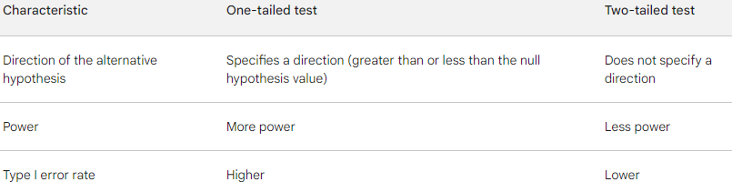

**31.What is experiment design, and why is it important?**

Experimental design is a statistical methodology that plans, executes, analyzes, and interprets experiments. It's a detailed plan for collecting and using data to identify causal relationships.

Experimental design is important because it:

* Allows researchers to make valid inferences about cause-and-effect relationships between variables
* Maximizes precision
* Ensures that the right type of data and a sufficient sample size and power are available to answer research questions
* Reduces the risk of making incorrect conclusions due to biases
* Ensures that studies using modern, non-animal approaches are planned and conducted correctly

Experimental design aims to:

* Identify the most relevant factors and their interactions
* Reduce the impact of variability
* Minimize the number of experimental runs required

An example of an experimental design would be randomly selecting all of the schools participating in a hand washing poster campaign. The schools would then randomly be assigned to either the poster-group or the control group, which would receive no posters in their bathroom.

**32.What are the key elements to consider when designing an experiment?**

The key elements to consider when designing an experiment are:

* Identify your variables. What are the factors that you are interested in studying? What is the independent variable (the variable that you will manipulate)? What is the dependent variable (the variable that you will measure)? What are the control variables (the variables that you will keep constant)?
* Write a specific, testable hypothesis. What do you predict will happen to the dependent variable when you manipulate the independent variable?
* Choose the appropriate experimental design. There are many different types of experimental designs, each with its own strengths and weaknesses. The type of design you choose will depend on your research question and the variables you are studying.
* Assign participants to groups. In some experimental designs, participants are randomly assigned to different groups. In other designs, participants are matched on certain characteristics to ensure that the groups are equivalent.
* Control for confounding variables. Confounding variables are variables that can influence the results of your experiment without you being aware of it. It is important to control for confounding variables by keeping them constant or by using a statistical technique called randomization.
* Collect data accurately and reliably. Once you have assigned participants to groups and controlled for confounding variables, you can begin collecting data. It is important to use valid and reliable measurement instruments to ensure that your data is accurate.
* Analyze your data and interpret your results. Once you have collected your data, you need to analyze it using statistical methods. This will help you to determine whether your results support your hypothesis.

Here are some additional tips for designing a good experiment:

* Make sure your experiment is unbiased. This means that you should design your experiment in a way that minimizes the risk of bias. For example, you should randomly assign participants to groups and control for confounding variables.
* Make sure your experiment is adequately powered. This means that you should have enough participants in your study to produce statistically meaningful results.
* Consider the range of applicability of your experiment. To what extent can you generalize your results to other populations or settings?
* Simplify your experiment. Only include the variables that are essential to your research question.
* Indicate the uncertainty in your results. No experiment is perfect. There will always be some uncertainty in the results. It is important to report this uncertainty in your findings.

By carefully considering all of these key elements, you can design an experiment that will produce reliable and informative results.

**33.What is the geometric interpretation of the dot product?**

The dot product, also known as the scalar product or inner product, is a mathematical operation that takes two vectors and returns a scalar (a single numerical value). Geometrically, the dot product has several important interpretations:

* Angle Between Vectors: One of the most fundamental geometric interpretations of the dot product is that it quantifies the relationship between the directions of two vectors. Specifically, the dot product of two vectors A and B is given by:  
  A · B = |A| * |B| * cos(θ)  
  where |A| and |B| are the magnitudes (lengths) of the vectors, and θ is the angle between them. The dot product is positive when the vectors are pointing in a similar direction (0° < θ < 90°), zero when they are orthogonal (θ = 90°), and negative when they are in opposite directions (90° < θ < 180°).
* Projection: The dot product can be used to find the projection of one vector onto another. If you have a vector A and you want to find the component of A in the direction of another vector B, you can use the dot product as follows:  
  Projection of A onto B = (A · B) / |B|  
  This projection represents the length of the shadow of vector A when it is cast onto the direction of vector B.
* Work and Force: In physics, the dot product has practical applications. If a force F is applied to an object and it is displaced by a distance d, the work done (W) is given by:  
  W = F · d  
  This equation represents the dot product of force and displacement. The dot product measures how much of the force is acting in the direction of the displacement.
* Orthogonality: If the dot product of two vectors is zero (A · B = 0), it means that the vectors are orthogonal (perpendicular) to each other. This property is fundamental in linear algebra and vector spaces.
* Proximity: In applications such as computer graphics and computer vision, the dot product is used to measure the similarity or alignment of two vectors. For example, in image processing, it can be used to compare the similarity of pixel values in different directions.
* 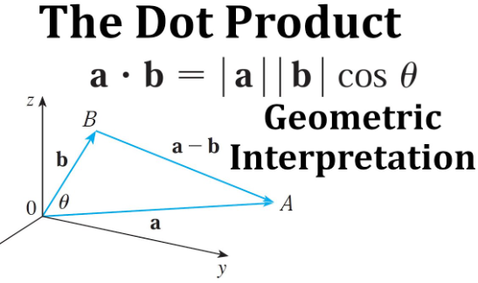

**34.What is the geometric interpretation of the cross-product?**

The geometric interpretation of the cross product is as follows:

The cross product of two vectors is a vector that is perpendicular to both of the original vectors, with a direction given by the right-hand rule and a magnitude equal to the area of the parallelogram that the vectors span.

In other words, the cross product tells us what direction a perpendicular vector would point in, and how long that vector would be.

* Orthogonality: One of the most fundamental geometric interpretations of the cross product is that it produces a vector that is orthogonal (perpendicular) to the plane formed by the two input vectors. If you have two vectors, A and B, and you take their cross product, denoted as A x B, the resulting vector is perpendicular to both A and B.
* Direction of Rotation: The right-hand rule is often used to determine the direction of the cross product vector. If you curl the fingers of your right hand from vector A to vector B, then your thumb points in the direction of A x B.
* Area of the Parallelogram: In 2D space, the magnitude of the cross product represents the area of the parallelogram formed by the two input vectors. This concept extends to 3D space as well. Specifically, the magnitude of A x B is given by:  
  |A x B| = |A| * |B| * sin(θ)  
  where |A| and |B| are the magnitudes of vectors A and B, and θ is the angle between them.
* Determinant of a 3x3 Matrix: In linear algebra, the cross product can be expressed as a determinant of a 3x3 matrix. If you have vectors A = (A1, A2, A3) and B = (B1, B2, B3), the cross product A x B is represented as:  
  A x B = (A2 * B3 - A3 * B2, A3 * B1 - A1 * B3, A1 * B2 - A2 * B1)  
  The resulting vector is orthogonal to the plane formed by vectors A and B.

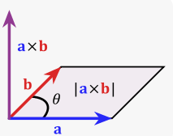

**35.What are observational and experimental data in statistics?**

Observational data and experimental data are two types of data that are collected for statistical analysis.

Observational data is data that is collected by observing a phenomenon or event without intervening. This type of data is often collected through surveys, questionnaires, or by observing people in their natural environment.

Experimental data is data that is collected by conducting an experiment. In an experiment, the researcher manipulates one or more variables and measures the effect on another variable. Experimental data is typically considered to be more reliable than observational data because it allows the researcher to control for other factors that could influence the results.

Here are some examples of observational data:

* The results of a survey on public opinion on a political issue.
* The number of cars that pass through a particular intersection in an hour.
* The heights and weights of students in a school.

Here are some examples of experimental data:

* The results of a clinical trial of a new drug.
* The effect of different types of fertilizer on the growth of plants.
* The effect of different teaching methods on student learning.

Both observational data and experimental data can be used to answer statistical questions. However, it is important to be aware of the limitations of each type of data. Observational data cannot be used to establish cause-and-effect relationships, while experimental data can. Additionally, experimental data is often more expensive and time-consuming to collect than observational data.

Which type of data is better depends on the specific research question being asked. If the researcher is interested in understanding the relationship between two or more variables, observational data may be sufficient. However, if the researcher is interested in establishing a cause-and-effect relationship, experimental data is necessary.

**36.What is the left-skewed distribution and the right-skewed distribution?**

A left-skewed distribution is a distribution in which the majority of the values are on the right side of the distribution, and the tail of the distribution extends to the left. This type of distribution is also known as a negative skew distribution.

A right-skewed distribution is a distribution in which the majority of the values are on the left side of the distribution, and the tail of the distribution extends to the right. This type of distribution is also known as a positive skew distribution.

Both left-skewed and right-skewed distributions are different from a normal distribution, which is a symmetrical distribution in which the majority of the values are in the middle of the distribution, with the tails of the distribution extending equally to the left and right.

Here are some examples of left-skewed and right-skewed distributions:

Left-skewed distributions:

* Income distribution
* Test scores
* Age of death
* Number of goals scored in a soccer match

Right-skewed distributions:

* Wealth distribution
* CEO salaries
* Home prices
* Number of children in a family

Left-skewed and right-skewed distributions can be important to consider when analyzing data, as they can affect the results of statistical tests. For example, if you are using a t-test to compare the means of two groups, and the data is not normally distributed, you may need to use a different test, such as a non-parametric test.

It is also important to note that left-skewed and right-skewed distributions can be caused by a variety of factors, such as the nature of the data being collected, the way the data is collected, or the presence of outliers. Therefore, it is important to carefully consider the context of the data before making any conclusions about the distribution.

**37.What is Bessel’s correction?**

Bessel's correction is a technique used to reduce the bias in the estimation of the population variance and standard deviation from a sample. It is named after the German mathematician Friedrich Bessel.

The population variance is the average of the squared deviations of all the values in the population from the population mean. The sample variance is the average of the squared deviations of all the values in the sample from the sample mean.

The sample variance is an unbiased estimator of the population variance if the sample is randomly selected from the population and the sample size is large. However, if the sample size is small, the sample variance is a biased estimator of the population variance. This is because the sample variance tends to underestimate the population variance.

Bessel's correction corrects for this bias by dividing the sample variance by n - 1, where n is the sample size. This results in an unbiased estimator of the population variance, even if the sample size is small.

Bessel's correction is a simple and effective way to reduce the bias in the estimation of the population variance and standard deviation from a sample. It is widely used in statistical analysis, and it is important to be aware of it when interpreting the results of statistical tests.

Here's the standard formula for calculating the sample variance:

Sample Variance (s^2) = Σ(x - x̄)^2 / (n)

Where:

* Σ represents the sum of values in the sample.
* x is an individual data point.
* x̄ is the sample mean.
* n is the number of data points in the sample.

The issue with this formula is that it assumes that you are working with the entire population (not a sample), and it divides the sum of squared differences by "n" to calculate the variance. When dealing with a sample rather than the entire population, dividing by "n" can lead to an underestimate of the true population variance.

Bessel's correction addresses this problem by adjusting the formula as follows:

Sample Variance with Bessel's Correction (s^2) = Σ(x - x̄)^2 / (n - 1)

In this adjusted formula, the sum of squared differences is divided by "n - 1" instead of just "n." The subtraction of 1 (n - 1) accounts for the degrees of freedom lost when estimating the population variance from a sample.

**38.What is kurtosis?**

Kurtosis is a statistical measure that quantifies the shape of a probability distribution. It is a measure of how peaked or flat the distribution is, and how heavy or light the tails are.

Kurtosis is calculated using the fourth central moment of a distribution, which is the average of the fourth powers of the deviations of the values in the distribution from the mean.

There are two main types of kurtosis:

* Positive kurtosis: This is also known as leptokurtosis. It means that the distribution is more peaked and has heavier tails than a normal distribution.
* Negative kurtosis: This is also known as platykurtosis. It means that the distribution is flatter and has lighter tails than a normal distribution.

A normal distribution has a kurtosis of 3. Distributions with a kurtosis greater than 3 are considered to be leptokurtic, and distributions with a kurtosis less than 3 are considered to be platykurtic.

Kurtosis can be a useful measure for understanding the characteristics of a distribution. For example, a high kurtosis distribution may indicate that there are outliers in the data. A low kurtosis distribution may indicate that the data is normally distributed.

Kurtosis is also used in a variety of statistical tests, such as the Shapiro-Wilk test and the Jarque-Bera test. These tests are used to test for normality, which is the assumption that the data is normally distributed.

Here are some examples of leptokurtic and platykurtic distributions:

* Leptokurtic distributions:
  + Student's t-distribution
  + Chi-squared distribution
  + Cauchy distribution
* Platykurtic distributions:
  + Uniform distribution
  + Exponential distribution
  + Beta distribution

Kurtosis is an important statistical measure that can be used to understand the characteristics of a distribution and to test for normality.

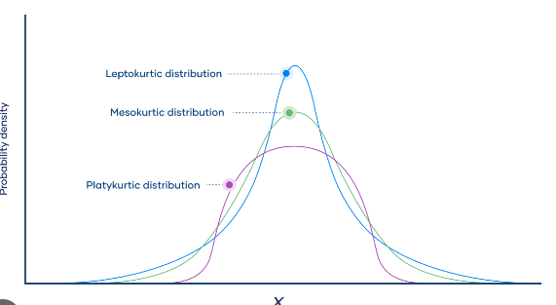

**39.What is the probability of throwing two fair dice when the sum is 5 and 8?**

To calculate the probability of getting a specific sum when throwing two fair six-sided dice, you can use a systematic approach. You'll find that the probability of getting a sum of 5 and 8 are different.

* Probability of Getting a Sum of 5: To get a sum of 5, you can have the following combinations:
* (1, 4)
* (2, 3)
* (3, 2)
* (4, 1)

There are four favorable outcomes. Since each die has 6 sides, there are 6 * 6 = 36 possible outcomes when throwing two dice.

So, the probability of getting a sum of 5 is:

Probability(5) = (Number of Favorable Outcomes) / (Total Possible Outcomes) = 4/36 = 1/9.

* Probability of Getting a Sum of 8: To get a sum of 8, you can have the following combinations:
* (2, 6)
* (3, 5)
* (4, 4)
* (5, 3)
* (6, 2)

There are five favorable outcomes, and as previously mentioned, there are 36 possible outcomes when throwing two dice.

So, the probability of getting a sum of 8 is:

Probability(8) = (Number of Favorable Outcomes) / (Total Possible Outcomes) = 5/36.

In summary:

* Probability of getting a sum of 5 is 1/9.
* Probability of getting a sum of 8 is 5/36.

**40.What is the difference between Descriptive and Inferential Statistics?**

Descriptive and inferential statistics are two different approaches to statistical analysis.

Descriptive statistics is used to summarize and describe the data. It provides information about the central tendency, variability, and distribution of the data. Descriptive statistics can be used to answer questions such as:

* What is the average height of the students in the class?
* What is the range of salaries for the company?
* What is the percentage of people who support a particular candidate?

Inferential statistics is used to make inferences about the population based on a sample. It uses statistical tests to determine whether the results of a sample are likely to be representative of the population as a whole. Inferential statistics can be used to answer questions such as:

* Is there a difference in the average height of boys and girls?
* Is the company's salary structure fair?
* Is the candidate's lead in the polls statistically significant?

The key difference between descriptive and inferential statistics is that descriptive statistics is used to describe the data, while inferential statistics is used to make inferences about the population.

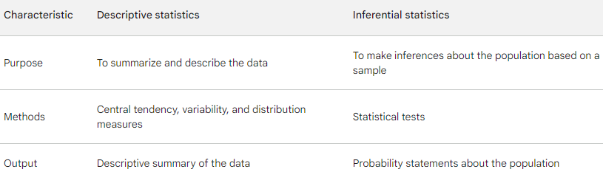

**41.What is the meaning of degrees of freedom (DF) in statistics?**

Degrees of freedom (DF) in statistics is the number of independent values in a statistical analysis that are free to vary. It is an essential idea that appears in many contexts throughout statistics including hypothesis tests, probability distributions, and linear regression.

The degrees of freedom in a statistical analysis depends on the specific test or model being used. For example, in a t-test for the difference between two means, the degrees of freedom is equal to the sample size minus two. This is because two parameters are estimated in a t-test: the population means of the two groups.

The degrees of freedom is important because it affects the distribution of the test statistic and the p-value. The p-value is the probability of obtaining a test statistic as extreme or more extreme than the one observed, assuming that the null hypothesis is true.

The smaller the degrees of freedom, the less information the data provides about the population parameters. This is because there are fewer independent values in the data that are free to vary. As a result, the p-value is more likely to be significant for a given test statistic when the degrees of freedom is small.

Here are some examples of how degrees of freedom is used in statistics:

* T-test: The degrees of freedom in a t-test for the difference between two means is equal to the sample size minus two.
* Chi-squared test: The degrees of freedom in a chi-squared test of independence is equal to the number of rows minus one times the number of columns minus one.
* Linear regression: The degrees of freedom in a linear regression model is equal to the sample size minus the number of independent variables in the model.

Degrees of freedom is an important concept in statistics because it affects the distribution of the test statistic and the p-value. It is important to understand how to calculate the degrees of freedom for the specific test or model being used in order to correctly interpret the results.

**42.What is the empirical rule in Statistics?**

The empirical rule is a statistical rule that states that for a normally distributed data set, approximately 68% of the values will fall within one standard deviation of the mean, 95% of the values will fall within two standard deviations of the mean, and 99.7% of the values will fall within three standard deviations of the mean.

The empirical rule is a useful tool for understanding the distribution of data and for making predictions. For example, if you know that a particular variable is normally distributed and the mean and standard deviation of the variable, you can use the empirical rule to predict the percentage of values that will fall within a certain range.

For example, suppose you know that the height of adult males is normally distributed with a mean of 175 cm and a standard deviation of 10 cm. You can use the empirical rule to predict that approximately 68% of adult males will be between 165 cm and 185 cm tall, 95% of adult males will be between 155 cm and 195 cm tall, and 99.7% of adult males will be between 145 cm and 205 cm tall.

The empirical rule is a powerful tool for understanding and analyzing data. It is widely used in a variety of fields, including statistics, economics, and finance.

Here are some examples of how the empirical rule can be used:

* Quality control: The empirical rule can be used to set control limits for quality control charts. Control limits are used to identify when a process is out of control.
* Risk analysis: The empirical rule can be used to assess the risk of certain events happening. For example, a financial analyst might use the empirical rule to assess the risk of a company losing money.
* Scientific research: The empirical rule can be used to interpret the results of scientific experiments. For example, a scientist might use the empirical rule to determine whether the results of an experiment are statistically significant.

The empirical rule is a valuable tool for understanding and analyzing data. It is a simple but powerful concept that can be used in a variety of fields.

**43.What is the relationship between sample size and power in hypothesis testing?**

Sample size and power are two important concepts in hypothesis testing. Sample size is the number of participants in a study, and power is the probability of correctly rejecting a false null hypothesis.

There is a positive relationship between sample size and power. This means that increasing the sample size will increase the power of the test. This is because a larger sample provides more information about the population, which makes it easier to detect a significant difference.

The following formula can be used to calculate the power of a hypothesis test:

Power = 1 - β

where β is the type II error rate, which is the probability of failing to reject a false null hypothesis.

The power of a hypothesis test can also be calculated using a power analysis calculator. A power analysis calculator takes into account the sample size, the significance level, and the effect size to calculate the power of the test.

It is important to note that there is a trade-off between sample size and power. Increasing the sample size will increase the power of the test, but it will also increase the cost and time required to conduct the study. Therefore, it is important to choose a sample size that is large enough to achieve the desired power, but also feasible to obtain.

Here are some examples of how the relationship between sample size and power can be used in hypothesis testing:

* A researcher is designing a study to test the effectiveness of a new drug for treating depression. The researcher wants to achieve a power of 80%. The researcher can use a power analysis calculator to determine the minimum sample size needed to achieve this power, given the expected effect size of the drug.
* A clinical trial is being conducted to test the safety of a new vaccine. The researchers want to achieve a power of 95%. The researchers will need to recruit a larger sample size for this trial than the previous trial, because the safety of a vaccine is a more serious concern than the effectiveness of a drug.

The relationship between sample size and power is an important concept in hypothesis testing. By understanding this relationship, researchers can design studies that are more likely to produce reliable results.

**44.What factors affect the width of a confidence interval?**

The width of a confidence interval is affected by three main factors:

* Sample size: The larger the sample size, the narrower the confidence interval. This is because a larger sample provides more information about the population, which makes it easier to estimate the population mean.
* Level of confidence: The higher the level of confidence, the wider the confidence interval. This is because a higher level of confidence means that we want to be more sure that the population mean is within the confidence interval.
* Population standard deviation: The greater the population standard deviation, the wider the confidence interval. This is because a greater population standard deviation means that the values in the population are more spread out, which makes it more difficult to estimate the population mean.

In addition to these three main factors, the width of a confidence interval can also be affected by the following:

* Choice of statistical test: Different statistical tests produce confidence intervals with different widths. For example, a t-test for the difference between two means will produce a wider confidence interval than a z-test for the difference between two means, if the sample sizes are small.
* Skewness of the population distribution: If the population distribution is skewed, the confidence interval may not be symmetrical. This means that the distance between the lower confidence bound and the population mean may be different from the distance between the upper confidence bound and the population mean.

It is important to note that there is always a trade-off between the width of a confidence interval and the level of confidence. If we want to be more confident that the population mean is within the confidence interval, we need to accept a wider confidence interval.

**45.What is a Sampling Error and how can it be reduced?**

A sampling error is a statistical error that occurs when a sample is not representative of the population. It is the difference between the sample statistic and the population parameter. Sampling errors can be both positive or negative, and can be caused by a variety of factors, such as:

* Sample size: The smaller the sample size, the more likely it is that the sample will not be representative of the population.
* Sampling method: If the sampling method is not random, the sample is more likely to be biased.
* Non-response: If some members of the population refuse to participate in the study, the sample may not be representative of the population.

Sampling errors can have a significant impact on the results of a study. If the sampling error is large, the results of the study may not be generalizable to the population.

There are a number of ways to reduce sampling errors:

* Increase the sample size: The larger the sample size, the less likely it is that the sample will not be representative of the population.
* Use a random sampling method: A random sampling method ensures that all members of the population have an equal chance of being selected for the sample.
* Reduce non-response: There are a number of ways to reduce non-response, such as using financial incentives, offering multiple follow-up attempts, and making the survey as short and easy to complete as possible.

In addition to the above, it is also important to carefully consider the research question and the population of interest when designing a study. This will help to ensure that the sample is representative of the population and that the results of the study are generalizable.

**46.What is a Chi-Square test?**

A chi-square test is a statistical test used to determine whether there is a significant association between two categorical variables in a contingency table. Contingency tables, also known as cross-tabulation tables or crosstabs, display the frequency distribution of categorical variables and allow you to examine if there's a relationship between them. The chi-square test helps assess the independence or dependence of these variables.

There are two common types of chi-square tests:

* Chi-Square Test of Independence (Chi-Square Test for Association):
  + This test is used when you want to determine whether there is an association or dependency between two categorical variables.
  + The null hypothesis (H0) in this test is that there is no association between the two variables, i.e., they are independent.
  + The test calculates an expected frequency for each cell in the contingency table if the variables are independent and then compares these expected frequencies with the observed frequencies from the actual data.
  + The chi-square statistic measures the discrepancy between the observed and expected frequencies. If the chi-square statistic is significantly different from what you would expect by chance, you reject the null hypothesis.
* Chi-Square Goodness of Fit Test:
  + This test is used when you want to assess whether a categorical dataset follows a particular theoretical distribution or expected frequencies.
  + The null hypothesis (H0) is that the observed data fit the expected distribution.
  + The test compares the observed frequencies in different categories with the expected frequencies that you specify. If there is a significant difference, you may reject the null hypothesis, suggesting that the observed data do not match the expected distribution.

The chi-square test is widely used in various fields, including social sciences, biology, and market research, for a range of applications. It provides a way to analyze categorical data and assess relationships between variables. However, it's important to note that the chi-square test assumes certain conditions, such as the variables being truly categorical and the sample size being sufficiently large for the test to be valid. If these assumptions are not met, alternative statistical tests may be more appropriate.

**47. What is a t-test?**

A t-test is a statistical hypothesis test used to determine if there is a significant difference between the means of two groups or conditions. It is a parametric test and is particularly useful when working with small sample sizes. The t-test compares the means of two groups and assesses whether the observed differences are likely due to random chance or if they represent a true difference in the population.

There are several variations of the t-test, but the two most common types are:

* Independent Samples T-Test: This t-test is used when you want to compare the means of two independent and unrelated groups to determine if they are significantly different. For example, you might use an independent samples t-test to compare the average test scores of two different groups of students (e.g., a control group and an experimental group).
* Paired Samples T-Test (Dependent T-Test): The paired samples t-test is used when you want to compare the means of two related groups or conditions, such as before and after measurements on the same individuals. For instance, it can be used to assess whether a treatment has had a significant effect within the same group of subjects.

The basic idea of the t-test is to calculate a t-statistic, which is a ratio of the difference between the sample means and the variability within the samples. The formula for the t-statistic is as follows:

t = (X̄1 - X̄2) / (s / √n)

Where:

* X̄1 and X̄2 are the sample means of the two groups.
* s is the pooled standard deviation, a measure of the variability within the samples.
* n is the number of observations in each group.

The t-statistic is then compared to a critical value from the t-distribution to determine whether the observed difference is statistically significant. The result is a p-value, which indicates the probability of obtaining such a difference by random chance. If the p-value is less than a predetermined significance level (e.g., 0.05), you would typically reject the null hypothesis, suggesting that there is a significant difference between the two groups.

T-tests are widely used in various fields, including science, psychology, and business, to compare groups and assess the significance of differences in means. They are essential tools for making informed decisions based on data analysis.

**48.How is hypothesis testing utilized in A/B testing for marketing campaigns?**

Hypothesis testing is used in A/B testing for marketing campaigns to determine which version of a campaign performs better. This is done by comparing the two versions of the campaign using a statistical test, such as a t-test or chi-squared test.

The first step in conducting an A/B test is to formulate a hypothesis. The hypothesis is a statement about what you expect the results of the test to be. For example, your hypothesis might be that version A of your campaign will have a higher conversion rate than version B.

Once you have formulated your hypothesis, you need to design the A/B test. This involves creating two versions of your campaign and randomly assigning visitors to one of the two versions. The two versions of the campaign should be identical, except for the variable that you are testing.

Once the A/B test is running, you need to collect data on the performance of each version. This data might include metrics such as conversion rate, click-through rate, and bounce rate.

Once the A/B test has run for a long enough period of time, you can analyze the data to determine whether your hypothesis was correct. You can do this by using a statistical test, such as a t-test or chi-squared test.

If the statistical test shows that there is a significant difference between the performance of the two versions of the campaign, then you can reject the null hypothesis and conclude that one version of the campaign performs better than the other.

Here is an example of how hypothesis testing is used in A/B testing for marketing campaigns:

A company is running an A/B test for a new email campaign. The company has created two versions of the email campaign, one with a red call-to-action button and one with a green call-to-action button. The company's hypothesis is that the version of the email campaign with the green call-to-action button will have a higher click-through rate.

The company randomly assigns visitors to one of the two versions of the email campaign. After the A/B test has run for a week, the company collects data on the click-through rate of each version.The company then uses a chi-squared test to compare the click-through rates of the two versions of the email campaign. The chi-squared test shows that there is a significant difference between the click-through rates of the two versions of the email campaign.Since the chi-squared test shows that there is a significant difference between the click-through rates of the two versions of the email campaign, the company can reject the null hypothesis and conclude that the version of the email campaign with the green call-to-action button has a higher click-through rate.

Hypothesis testing is an important tool for A/B testing because it allows marketers to determine which version of a campaign performs better in a statistically significant way. This information can then be used to improve future marketing campaigns.



**49.What is the difference between one-tailed and two tailed t-tests?**

The main difference between one-tailed and two-tailed t-tests is the direction of the alternative hypothesis.

In a one-tailed t-test, the alternative hypothesis specifies the direction of the difference between the means of the two groups. For example, the alternative hypothesis might be that the mean of group A is greater than the mean of group B.

In a two-tailed t-test, the alternative hypothesis does not specify the direction of the difference between the means of the two groups. For example, the alternative hypothesis might be that the mean of group A is different from the mean of group B.

Another difference between one-tailed and two-tailed t-tests is the critical value. The critical value is the t-statistic that must be exceeded in order to reject the null hypothesis. The critical value for a one-tailed t-test is smaller than the critical value for a two-tailed t-test.

This is because a one-tailed t-test is more sensitive to differences in the direction specified by the alternative hypothesis. In other words, a one-tailed t-test is more likely to reject the null hypothesis if the difference between the means of the two groups is in the direction specified by the alternative hypothesis.

Here is a table that summarizes the key differences between one-tailed and two-tailed t-tests:

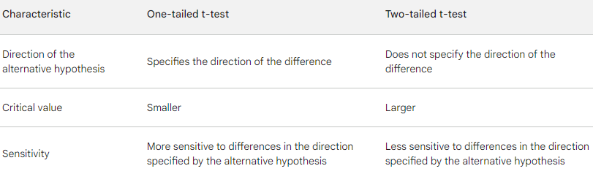

**50.What is an inlier?**

An inlier is a data point that lies within the interior of a statistical distribution and is in error. It is an observation lying within the general distribution of other observed values, generally does not perturb the results but is nevertheless non-conforming and unusual.

Inliers can be caused by a variety of factors, such as:

* Measurement errors: An inlier may be caused by a measurement error, such as a typo in a spreadsheet or a faulty measuring instrument.
* Data entry errors: An inlier may be caused by a data entry error, such as typing in the wrong number or entering a date in the wrong format.
* Fraud: An inlier may be caused by fraud, such as a salesperson entering fake data to boost their sales numbers.

Inliers can be difficult to identify because they lie within the interior of the distribution. However, there are a number of techniques that can be used to identify inliers, such as:

* Boxplots: Boxplots can be used to identify inliers as data points that fall outside of the whiskers.
* Histograms: Histograms can be used to identify inliers as data points that fall outside of the main body of the distribution.
* Z-scores: Z-scores can be used to identify inliers as data points that have a z-score greater than 3 or less than -3.

Once an inlier has been identified, it is important to investigate the cause of the inlier and to correct it if necessary. If the inlier is caused by a measurement error or data entry error, the data point should be corrected. If the inlier is caused by fraud, the appropriate disciplinary action should be taken.

It is important to note that not all inliers are errors. In some cases, an inlier may represent a legitimate but unusual data point. For example, if you are collecting data on the weight of people, an inlier may represent the weight of a person who is very tall or very muscular.

In general, it is important to be aware of the potential for inliers in your data and to take steps to identify and correct them.